Filling the Dental Gap:
Caring for Medicaid Clients with Dental Coverage
January 2015

Introduction
Colorado reached a historic milestone in 2014 when it began offering dental insurance to each of the state’s 1.1 million Medicaid clients. This places Colorado among the nation’s leaders when it comes to oral health coverage for those with the lowest incomes.
It also presents a significant challenge: Ensuring that these new enrollees, many with longstanding oral health issues, can find care in a state already struggling to field an adequate oral health workforce to serve lower-income Coloradans.
The number of Medicaid clients with dental benefits has tripled in little more than two years because of two important policy changes in Colorado – expanding Medicaid eligibility and extending Medicaid dental benefits to adults. The number of registered dentists and other professionals has climbed as well – but not nearly as fast.
This new analysis by the Colorado Health Institute (CHI), building on research published in 2013, finds a widening gap between the demand for oral health care by Medicaid enrollees and the supply of oral health providers. The situation is especially tough for Medicaid enrollees in 15 Colorado counties. Eight of them are dental deserts – areas that do not have any dental care at all. The other seven counties do not have a privately practicing dentist who accepts Medicaid or a safety net clinic offering dental services.
There has been some encouraging progress. The number of privately practicing dentists who treated Medicaid enrollees increased by 125 dentists, or 17 percent, from 2012 to 2014.
Still, getting oral health care is difficult, if not impossible, for many of Colorado’s Medicaid clients. The Colorado Department of Public Health and Environment (CDPHE) estimates that Colorado needs an additional 87 dentists to meet the need for dental care in underserved regions across the state.
And CHI projects an even wider gap as Medicaid enrollment increases to a projected 1.3 million people in 2016. Safety net leaders on the front lines already report significant pent-up demand, full schedules, and even having to turn away enrollees.
CHI’s bottom line finding is that Colorado currently doesn’t have the ability to provide oral health care to all of its residents with dental benefits.

Colorado’s Oral Health Workforce: An Overview
Colorado had 3,880 licensed dentists in 2014, up four percent from 3,730 in 2013. This is a starting point for understanding Colorado’s dentist workforce.
But not every dentist with a license is actually practicing. (Please see Graphic 1.) Some may live out of state but maintain a license in Colorado where they vacation or have family. Others may have left practice. Of Colorado’s 3,880 licensed dentists, CHI estimates that 2,654 are actively working in private practices.
Graphic 1:
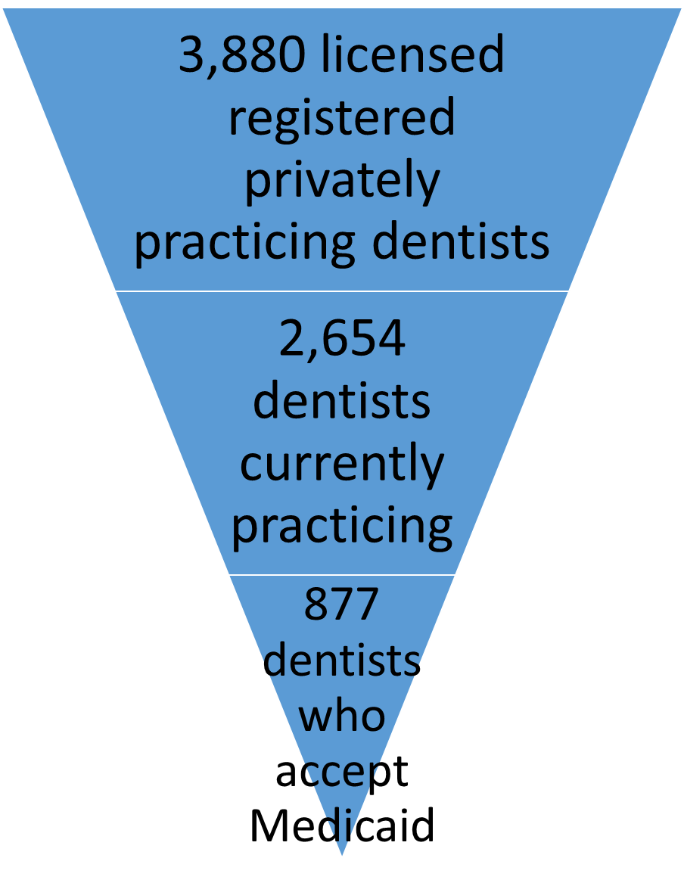
This translates to about one privately practicing dentist for each 2,022 residents statewide.
Opinions differ on whether that is an adequate ratio. For example, a county with one full-time equivalent (FTE) dentist for each 4,000 residents is eligible to be a Dental Health Professional Shortage Area. Colorado’s statewide ratio is much better.
What is certain is that the statewide dentist-to-resident ratio masks wide variation by county. For example, while Ouray County in southwest Colorado has one dentist for each 1,193 residents, Kit Carson County on the Eastern Plains has just one dentist for each 8,162 residents.
Eight of Colorado’s 64 counties are ‘dental deserts’ – meaning they have no privately practicing dentists, no Federally Qualified Health Centers (FQHCs) with dental services and no Community-Based Dental Clinics (CBDCs). (see Map 1).
Colorado is one of only 10 states that is without a dentist in more than 10 percent of its counties. Still, the eight counties without access to a dentist account for less than one percent of Colorado’s total population.
Not all privately practicing dentists participate in the Medicaid program. In 2014, there were 877 dentists providing services to at least one Medicaid enrollee.
Meanwhile, the safety net is another important provider of dental care in Colorado. CHI estimates that more than 100 dentists are providing dental services in publicly-funded FQHCs or CBDCs. In this analysis, dentists in FQHCs and CBDCs are not considered privately practicing.
FQHCs serve low-income patients in medically underserved areas and medically underserved populations, offering sliding fee scales. Colorado has more than 60 FQHC dental clinics with approximately 300 full-time equivalent (FTE) dental employees. The FQHCs receive a fixed payment from Medicaid each time they care for a client, regardless of the services they provide.
CBDCs serve the same population as FQHCs – those who have low incomes, who don’t have health insurance, or who have Medicaid or Child Health Plan Plus (CHP+) coverage but can’t find a dental provider to accept their insurance.
Nine CBDCs are located in five Colorado counties. The clinics are staffed by dentists, hygienists and other dental providers. CBDCs receive different Medicaid payments than FQHCs. Medicaid pays CBDC providers on a fee-for-service basis at the same rates as private practice dentists billing Medicaid.
There are other critical partners in the oral health workforce. While dental hygienists provide high-quality oral health education and preventive services, they are not included in this analysis due to limited data.

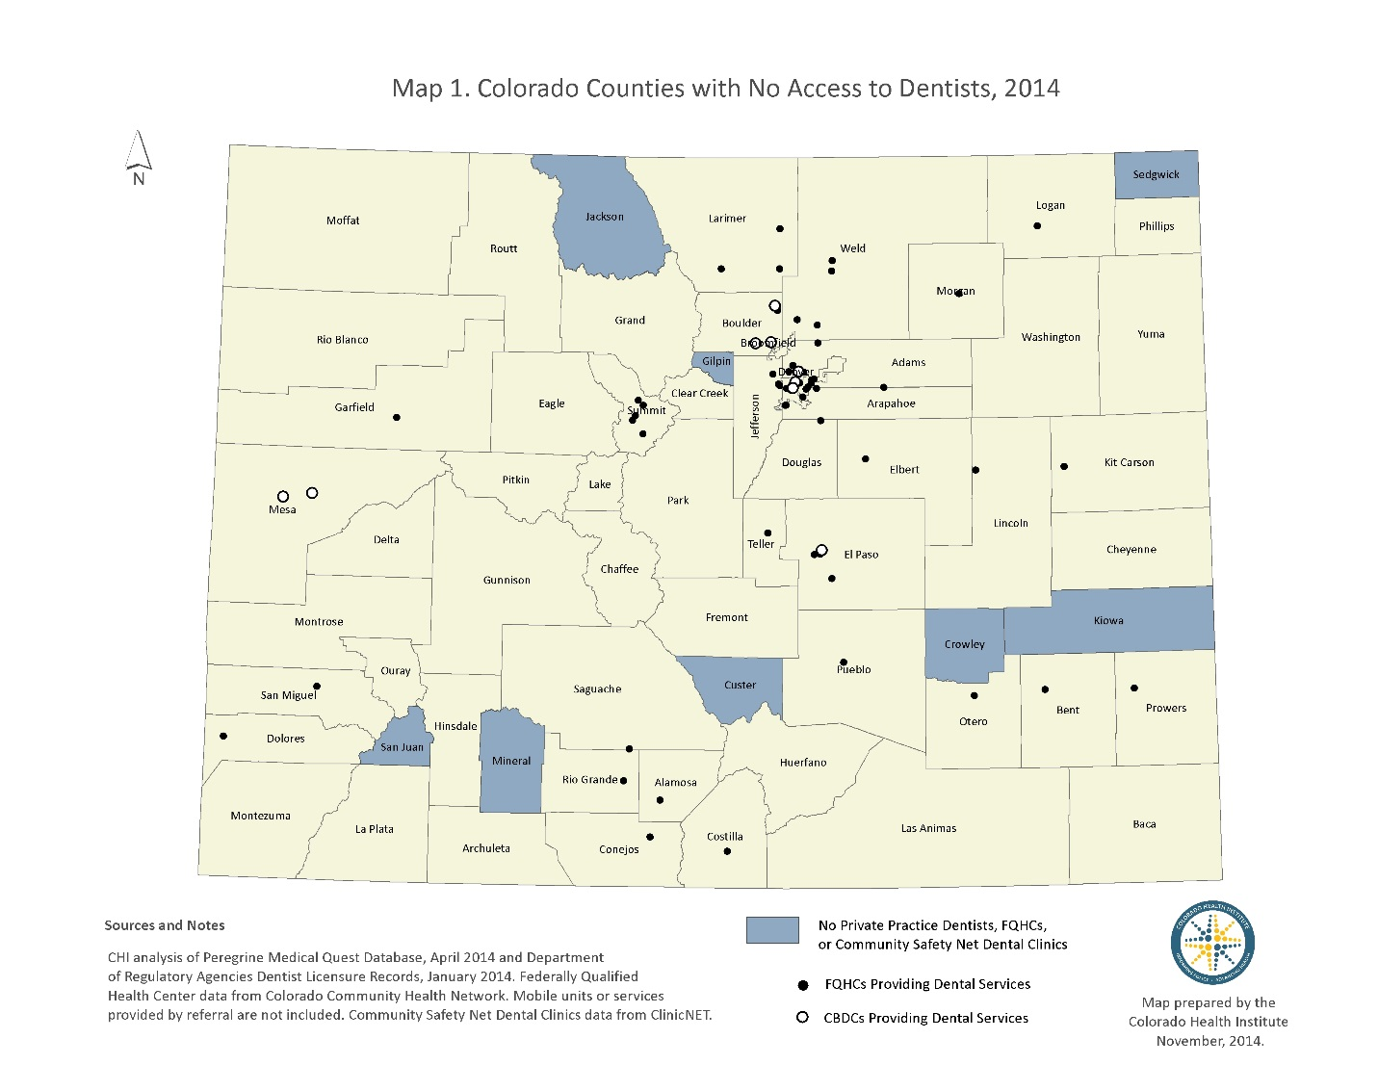

A Changing State: New Oral Health Policy
Two Colorado policy changes are prompting the big shifts in the oral health landscape.
The legislature voted in 2013 to expand Medicaid eligibility to people with slightly higher incomes as well as to childless adults, who traditionally did not qualify for the public insurance program. The Affordable Care Act had required the expansion, but it became optional in the wake of a Supreme Court ruling. Colorado joined 26 other states and the District of Columbia in choosing to go ahead.
The decision means that most people earning below 138 percent of the federal poverty level – $16,105 for a single person and $32,913 for a family of four – are now eligible for Medicaid. It also means that Colorado has seen a spike in Medicaid enrollment, climbing from 744,085 in September 2013, just before the expansion was implemented, to 1.1 million in September 2014 – a 49 percent increase.
Today, almost one of five Coloradans is a Medicaid enrollee.
Meanwhile, Colorado extended Medicaid dental benefits, which had been available only to children and adolescents, to adults over the age of 21. Medicaid rolled out the adult dental benefits in two stages in 2014.
Adults gained annual coverage for basic preventive, diagnostic and minor restorative services in April. Three months later, on July 1, the second phase kicked in covering more comprehensive services such as root canals, crowns and dentures. The annual coverage cap is set at $1,000, except for emergency services and dentures.
Before the expansion, Colorado Medicaid was providing dental benefits to about 350,000 children and adolescents. Now, Medicaid benefits are available for all 1.1 million enrollees.
Early signs indicate a great deal of pent-up demand among those who gained dental benefits in 2014.
Medicaid’s dental monthly expenditures increased 68 percent from $11 million between July and December 2013, before the benefits were extended, to $18.5 million during the same time period in 2014, after adults gained the dental benefit. By comparison, enrollment increased by 49 percent during that time.
Many enrollees quickly reach their $1,000 benefit cap, according to safety net providers who serve low-income and uninsured Coloradans. Many of these clinics are struggling to care for the influx of patients. Safety net clinics are fully booked as far as their scheduling policy allows – one to three months, according to members of Oral Health Colorado’s Access to Care Committee.

Medicaid Expansion: A Closer Look

A better understanding of the growth in Medicaid enrollment will help to provide answers about the increased need for dental services in this population. While statewide enrollment shot up 49 percent between September 2013 and September 2014, some counties experienced larger increases than others.

Roughly half of Colorado’s 64 counties saw their Medicaid enrollment grow by more than 50 percent during that one-year time period. The other half experienced growth of between 29 percent and 50 percent.

Nearly half of the residents of Costilla County in the San Luis Valley are Medicaid clients, the state’s highest rate. Two other nearby counties in the San Luis Valley, Alamosa and Conejos, have Medicaid enrollments of more than 40 percent of their populations.

Five counties with the highest county percentage of Medicaid enrollees in September 2014:

- Costilla County: 47.7 percent
- Alamosa County: 41.6 percent
- Conejos County: 40.4 percent
- Otero County: 38.1 percent
- Saguache County: 38.0 percent

Among urban counties, one of four residents of Denver County (27 percent) and Adams County (26 percent) are Medicaid enrollees.

Northeast Colorado and the Eastern Plains fall toward the bottom of the percentage change in Medicaid enrollment (see Map 2.) Counties with the lowest rates of growth include Logan, Sedgwick, Morgan and Yuma in the northeast and Crowley, Otero, and Prowers on the Eastern Plains.

Some mountain resort counties – Grand, Pitkin, Summit, Eagle and Park – showed significant enrollment growth. Pitkin County tops the list with an increase of 177 percent, growing from 447 Medicaid enrollees in 2013 to 1,240 enrollees in 2014.

Indeed, many of the counties showing the fastest Medicaid growth started with small enrollments.
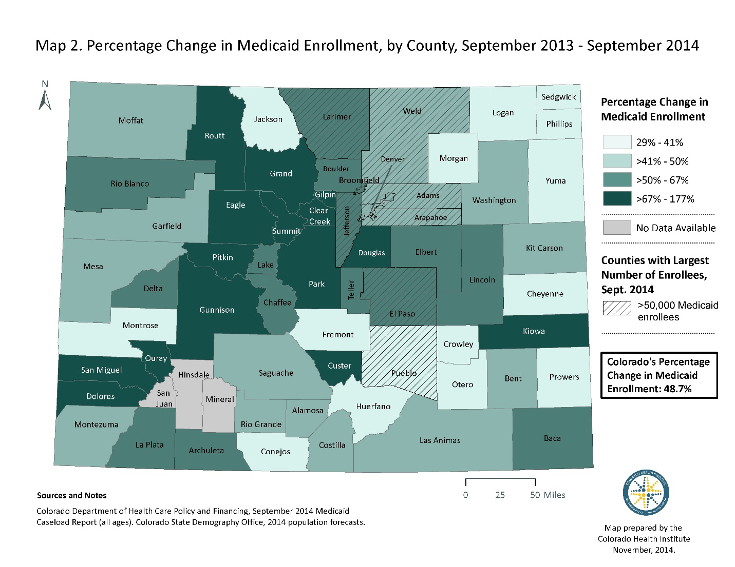

Privately-Practicing Dentists Who Treat Medicaid Enrollees
Gaining dental insurance is only part of the access-to-care puzzle. Colorado needs an adequate pool of dentists who accept Medicaid to care for Colorado’s burgeoning Medicaid population.
In addition to Colorado’s eight dental desert counties, another seven – Philips, Yuma, Washington, Park, Pitkin, Delta and Ouray – have no source of Medicaid dental care. (See Map 3.) This means they do not have an FQHC, CDBC or any privately practicing dentists who have accepted Medicaid.
These 15 counties account for only two percent of the state’s total Medicaid population. In another 10 counties, FQHCs are the only source of dental care.
Meanwhile, access to care may be tough even in counties with providers. Enrollees in some sparsely-populated regions are hard-pressed to find a dentist. Along the Eastern Plains, enrollees in Yuma, Washington and Phillips counties may need to travel to Morgan or Logan counties for care. Medicaid clients in Yuma County commonly travel 90 miles to reach the nearest dentist.
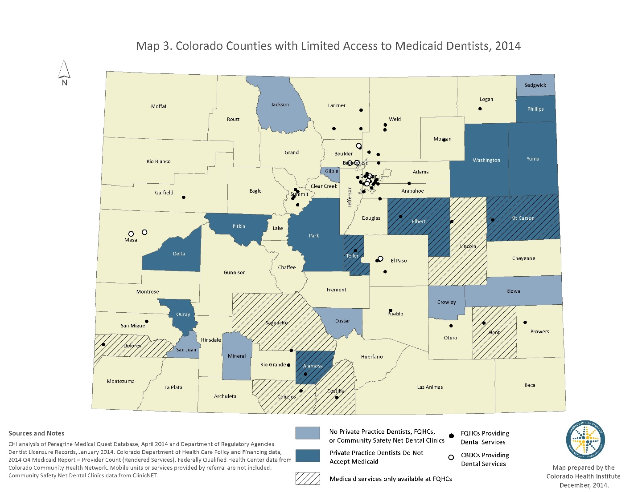

CHI estimates that about one of three dentists actively working in private practices have treated Medicaid enrollees – 877 of the 2,654 dentists.
But there is wide variation across the 39 counties that have dentists accepting Medicaid. (See Map 4.) And there is additional variation among dentists. Some may treat only a few enrollees while others may treat many more. For example, five percent of the dentists who provided Medicaid services treated 44 percent of Medicaid dental clients in FY 2013-14.
Counties in northeast Colorado and the Eastern Plains have few private practice dentists accepting Medicaid, even though Medicaid enrollees make up about a quarter of their populations. Philips, Washington, Elbert, Yuma and Kit Carson counties all have private practice dentists, but none accepting Medicaid.
Some of Colorado’s more prosperous counties, including Broomfield, Eagle, Douglas, Boulder and Grand, have the lowest percentages of privately practicing dentists accepting Medicaid.
Eagle and Grand counties do not have FQHCs or CBDCs, further limiting access for Medicaid enrollees. Located along the Front Range, Broomfield has 6,014 Medicaid enrollees, but only one of its 31 private practice dentists has treated Medicaid clients.
Only six counties – Adams, Cheyenne, Huerfano, Moffat, Hinsdale and Pueblo – have 75 percent or more of private dentists accepting Medicaid.
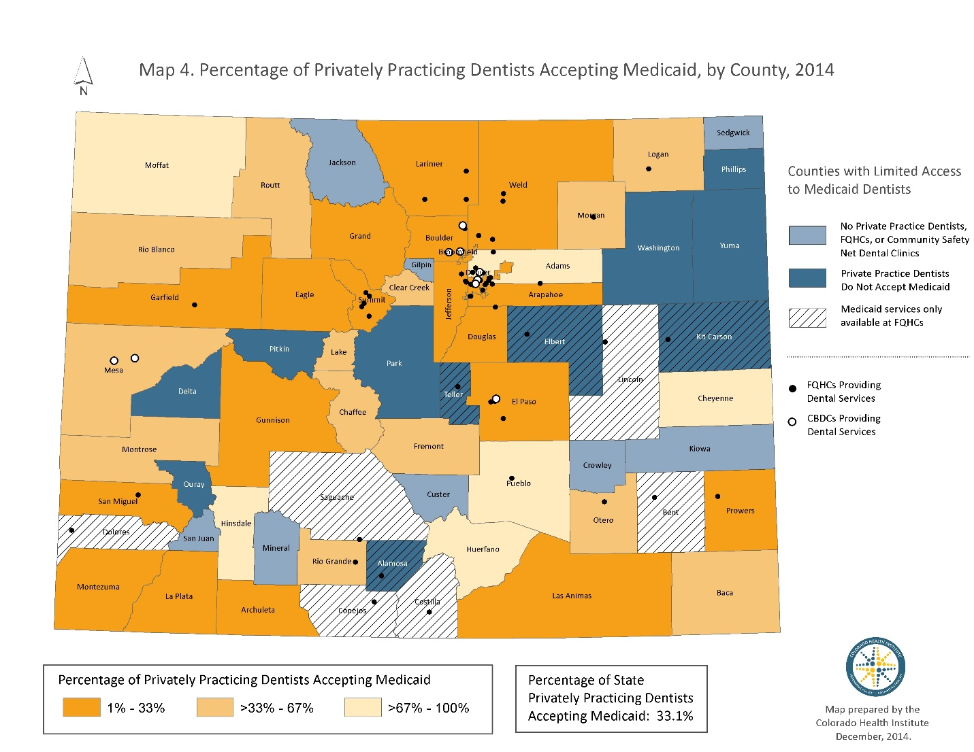
Still, Colorado’s Medicaid dentist workforce is trending in a positive direction. The number of dentists who treated Medicaid clients increased 17 percent from 752 dentists in 2012 to 877 dentists in 2014. Much of that increase was clustered in these six urban counties:
- Adams: +48
- Denver: +16
- Jefferson: +13
- Arapahoe: +11
- Larimer: +10
- El Paso: +9
Six counties saw a decline in dentists treating Medicaid enrollees, including Pueblo County, which lost five Medicaid dentists.

Where the Medicaid Supply Does – or Doesn’t – Meet Demand
CHI’s analysis finds that many of the counties with the biggest increases in demand for Medicaid dental care have not seen a corresponding increase in the supply of dental providers.
- Counties with the Largest Increase in Medicaid Enrollees
Many counties with the highest percentage increase in Medicaid enrollees are clustered around the mountain resort region. (See Map 2). And many residents in these areas have little or no access to Medicaid dental care. For example, Eagle County has only one Medicaid-accepting dentist for each 3,169 Medicaid enrollees.
Some of these counties, however, are showing improvement. Routt County, for example, saw Medicaid enrollment increase nearly 85 percent from 2012 to 2014. About 44 percent of private practice dentists now accept Medicaid, up from about 25 percent in 2012.
This translates to a healthy supply of Medicaid dental providers in Routt County, about one for each 452 Medicaid enrollees.
- Counties with the Largest Number of Medicaid Enrollees
Colorado’s most populated counties have the largest number of Medicaid enrollees, as would be expected. Eight counties along the Front Range – Larimer, Weld, Denver, Adams, Arapahoe, Jefferson, El Paso and Pueblo – are home to 75 percent of the Medicaid population.
These counties average about one Medicaid-accepting dentist for each 1,300 enrollees.
Weld County, however, has just one Medicaid-accepting dentist for each 2,554 enrollees. In contrast, Pueblo has a little more than one Medicaid-accepting dentist for each 1,000 enrollees and Adams County has one Medicaid dentist for each 753 Medicaid clients. Adams County saw an additional 48 dentists began accepting Medicaid between 2012 and 2014.
- Counties with the Highest Rates of Medicaid Enrollees
Medicaid clients in the San Luis Valley, which has the highest rates of Medicaid enrollees, depend primarily on FQHCs for dental services. For example, Saguache, Alamosa, Conejos and Costilla counties do not have any privately practicing dentists accepting Medicaid. Rio Grande County’s enrollees have slightly better access, receiving care from the county’s FQHC or two privately practicing dentists who accept Medicaid.
FQHCs in counties with high rates of Medicaid enrollees are already at full capacity. In three counties – Conejos, Costilla and Saguache -- FQHCs are the only source of dental care for any resident. For example, one FQHC serves Conejos County’s 8,410 residents.

The Safety Net: Learning From a Crucial Provider
Colorado’s health care safety net is often the only source of dental care for Medicaid enrollees as well as Coloradans who are uninsured or underinsured.
Because the safety net plays such a crucial role, CHI interviewed a number of leaders to better understand the challenges in meeting the increased demand, synthesizing the findings within these four themes:
- Case Management is a Pressing Need.
Most Medicaid clients with new dental benefits are excited about the coverage, but may be confused about the services that are covered and how to go about getting care. Many clients assume that a couple appointments will resolve their needs and fall within the $1,000 annual cap, but they often need more extensive services that aren’t fully covered. Also, some procedures require pre-authorization. Educating clients and guiding them through this new world is falling to the clinics, but they don’t have the resources and aren’t compensated for this work.

- Payment Model May Force Changes.

The dental care payment mix is changing dramatically, with an increasing proportion coming from Medicaid and a declining proportion from uninsured clients who pay based on a sliding fee scale. FQHCs generally welcome this change because they are usually able to recoup the full cost of treatment from Medicaid. But some CBDCs face a drop in revenue because Medicaid’s fee-for-service schedule provides less revenue than their previous sliding fee scales. This may force the CBDCs to limit their Medicaid clients.

- The Safety Net Has Limited Capacity to Add Patients.

Colorado’s safety net has made small increases in its dental services since 2013. FQHCs added three dentist FTEs and expanded dental services at several school-based health centers. However, demand for these services is high. FQHCs provide the only source of local dental care for all residents, not just those enrolled in Medicaid, in six counties – Dolores, Saguache, Conejos, Costilla, Lincoln and Bent. Some safety net clinics were at full capacity before the additional dental benefits kicked in, and many more have reached the point where they can no longer accept new patients.
Clinica Family Health Services, an FQHC serving Boulder and Adams counties, said that its dental clinic was full before the Medicaid dental benefit went into effect. Its pediatric dentists are often at maximum capacity and dentists were already booked with uninsured adults. Although many of these previously uninsured adults are now covered by Medicaid, Clinica staff is working to complete their treatment plans to open up space for new patients.

Was Colorado Ready?
Colorado policymakers and the oral health community, anticipating a surge in demand, developed a number of policies and programs to increase the state’s Medicaid dental provider network. While some of these efforts have been in place long enough to be evaluated, others are just being implemented.
These are some of the important steps that have been taken to meet the increased demand for dental care. There is much more work to be done to ensure access to care for those who need it.
- Payment Reform
Colorado increased how much it pays dental providers who treat Medicaid enrollees, approving a 4.5 percent rate increase in FY 2013-14 and a two percent increase in FY 2014-15. Colorado also has returned to a more generous method for calculating FQHC reimbursement rates that it used prior to the recession.
Still, Medicaid’s pays on average a bit less than half of the private market reimbursement rate for common preventive and treatment services.

Colorado is trying to close the pay gap. The legislature has approved $2.5 million to match federal funds in order to provide financial incentives for dentists to treat more Medicaid enrollees. But Colorado is awaiting federal approval to enact the incentives. And even if the program is approved, the window for providers to enroll and see new Medicaid enrollees is narrowing.

The proposal calls for a dentist to receive a total of $3,000 for seeing 105 new Medicaid clients twice each by next July. A dental hygienist can receive $1,500 for 105 new Medicaid clients.
The formulas for this new incentive program are:
Dentists:
- $1,000 for five new clients seen twice between July 1, 2014 and June 30, 2015.
- $1,000 for the next 50 new clients
- $1,000 for the next 50 new clients

Independent Dental Hygienists
- $500 for five new clients seen twice between July 1, 2014 and June 30, 2015.
- $500 for the next 50 new clients
- $500 for the next 50 new clients

- Program Administration
Colorado has shifted the administration of the Medicaid dental benefit from the Department of Health Care Policy and Financing (HCPF) to DentaQuest, which has taken over provider recruitment and training, enrollee relations, claims and payment.
Boston-based DentaQuest is a private corporation that administers state-sponsored dental programs to more than 20 million public insurance clients nationwide. It also supports clinical research through its DentaQuest Institute and works to improve oral health through its DentaQuest Foundation.
Colorado’s goal is to be more efficient and create a program that is friendlier to providers and consumers. Contracting with DentaQuest was a key strategy to achieve this goal. DentaQuest’s contract includes incentives for quality and improved access. It receives a per member per month payment (PMPM) from the state for each Medicaid enrollee. This PMPM can increase by meeting goals, including expanding the Medicaid dental provider network by at least 150, decreasing dental emergency room visits by 30 percent and increasing preventive dental services for enrollees.
DentaQuest must report each month on its steps to improve access to dental care, especially in counties with few providers.

Bridging the Gap
Colorado’s ability to provide dental care for Medicaid clients will be further strained as enrollment climbs in the coming years. Creative solutions are being tested across Colorado that may yield learnings that can be scaled up statewide.
A number of programs hold promise in ensuring that Colorado’s Medicaid clients can get dental care:
- Community Facilitation: The Health District of Northern Larimer County, a special tax district which subsidizes low-income health care, is planning to expand a partnership with local dentists who provide pro bono or sliding scale services through the Dental Connections program. A new campaign will reach out to providers, offering help with Medicaid applications and serving as a “caseload distribution hub” to match Medicaid clients to available dentists.
- Integrating Preventive Dental Care and Primary Care: Clinica Family Health Services found that few of its patients were using its preventive dental services. And data showed that, on average, children were seven before their first dental visit. In response, Clinica moved preventive dental care into its medical clinics. Now, each primary care team includes a dental hygienist who assesses and educates patients, applies fluoride varnish, and organizes dental clinic appointments. After two years, the average age of the first dental visit has dropped to about four. Meanwhile, the Delta Dental of Colorado Foundation is launching a five-year initiative to co-locate dental hygienists in pediatric primary care practices. The new initiative, building off a successful three-year pilot in five pediatric primary care practices, will expand the program to 10 additional practices. Delta Dental plans to evaluate the impact of the program on oral health behavior, oral health outcomes and financial sustainability.
- Hub-and-Spoke: The hub-and-spoke model entails a dental professional visiting outlying areas from his or her primary practice on a regular basis to provide care in geographic areas with limited access. Following this model, the Northwest Colorado Visiting Nurse Association (NWCOVNA) and North Park Medical Center (NPMC) are working together to bring a dentist to Walden, located in Jackson County, one day a month. The dentist, who has a practice in Granby, lacked office space and equipment to expand to Jackson County as part of a hub-and-spoke service model. So NWCOVNA tapped funding from the Colorado Department of Public Health and Environment to purchase equipment and NPMC donated space and additional supplies. The dentist is expecting to begin seeing patients in February 2015. Similarly, one dentist who practices and resides in Denver routinely travels to Hinsdale County in the Southwest, providing the county’s only Medicaid dental care two times a week, every other week. This model could also be attractive for other areas of the Southwest and Eastern Plains, where geographic barriers and small populations may make it difficult to support a full time dental practice.
Meanwhile, these policies are also being tested:
- Broaden the Scope of Dental Providers: Lawmakers made several changes affecting education and license requirements for dentists and dental hygienists during the 2014 legislative session as part of a sunset review of the Dental Practice Act. For example, continuing education will be required for renewing, reactivating or reinstating a dental and dental hygiene license. Stakeholders, meanwhile, are analyzing efforts in other states in preparation for introducing expanded “scope of practice” legislation for dental hygienists in Colorado.

Scope of practice defines the procedures professionals licensed by the state are allowed to perform. One proposal expected to be put forward in the 2015 session likely will be based on a pilot program in California called the Virtual Dental Home, which creates web-based connections between dentists and dental hygienists working in community settings such as schools or child care facilities. The hygienists provide preventive care, screening, X-rays and treatment planning in virtual collaboration with the dentists, who review screening results and X-rays. Hygienists also have the authority to place temporary fillings as an interim measure before the patient sees a dentist.

Although three states – Minnesota, Alaska and Maine – have created a role for dental therapists, Colorado stakeholders are not focusing on bringing this controversial proposal to the legislature. Dental therapists are trained to provide a broad slate of preventive dental care services as well as relatively basic restorative treatments such as tooth extractions and fillings. The dental provider community remains at odds whether to create a new provider type like therapists or more fully utilize existing dental health professionals.

- Build A Dental Workforce That Accepts Medicaid: Over the past two years, significant strides have been made in increasing the Medicaid dental workforce. However, due to the large increase in the Medicaid population with oral health benefits, more work remains. Short- and long-term strategies are in place to increase the number of dentists accepting Medicaid, including the proposed state-federal incentive program and DentaQuest’s goals for provider recruitment. The Colorado Dental Association is encouraging members to add Medicaid enrollees to their practices. These efforts to engage privately practicing dentists, however, may take time to yield results.

- Plan for the Future: The Colorado Health Service Corps provides loan repayments for dentists and dental hygienists who accept Medicaid and agree to practice in communities with few dental providers. The program provided loan repayments for 22 dentists and five registered dental hygienists in FY 2013-14. Two dentists will begin three-year contracts supported by loan repayment in 2015. CDPHE is requesting $1.7 million in state funds for FY 2015-2016 to increase the number of providers who receive loan repayments.

Conclusion
Colorado has taken an important step to improve oral health by extending dental benefits to all Medicaid enrollees. Lawmakers, providers, public health partners, philanthropies and community advocates achieved a significant victory in improving oral health across the state.
However much work lies ahead.
Safety net providers are working hard to meet the demand. But CHI’s findings beg the question of where today’s Medicaid dentally insured and those to be added in the coming years will find care.
Policies are already in place. The difficult task of implementation and achieving meaningful solutions – improved oral health for Medicaid enrollees – remains.

Methodology
Private Practice Dentists
The number of private practice dentists in each county is derived from the Peregrine MedicalQuest database and the Department of Regulatory Agencies (DORA) dentist licensure data. CHI used DORA data to establish an initial count of dentists licensed and practicing in Colorado. CHI then verified practice locations of all dentists in the DORA database with a Colorado address that was not listed in the Peregrine database through online search and randomly-selected direct inquiries. A dentist was counted as practicing in a county based on unduplicated records and primary location address. CHI focused its analysis on dentists who are licensed to provide a full spectrum of the services that are covered by Medicaid. CHI removed the dentists who work at Federally Qualified Health Centers (FQHCs) and Community-Based Dental Clinics (CBDCs) from this count in order to compare Medicaid caseload data with private practice dentists accepting Medicaid. Dentists working in a military establishment or correctional facility were also removed from the analysis.
Private Practice Dentists Accepting Medicaid
The Colorado Department of Health Care Policy and Financing’s (HCPF) quarterly dental benefits management report is the source for the numbers of private practice dentists who accept Medicaid. HCPF data include any dentist who provided services to Medicaid enrollees in fiscal year FY 2013-14. Due to data limitations, it is not possible to determine the number of Medicaid enrollees a private practice dentist served.
Federally Qualified Health Centers (FQHCs)
FQHCs are required by federal regulations to provide dental services directly or by referral. They primarily serve Medicaid enrollees. FQHC data are from the Colorado Community Health Network and show the number and county location of clinics that provided dental services directly as of July 2014. Mobile clinics were not included in the analysis.
Community-based Dental Clinics (CBDCs)
Many organizations that are not affiliated with FQHCs are considered part of the safety net. This analysis includes the locations of Community-Based Dental Clinics that are members of ClinicNet. ClinicNet provided CHI with data on the number and location of clinics.
Medicaid Enrollment
2014 Medicaid enrollees include all current enrollees as of September 2014 based on data supplied by HCPF.

Endnotes

Joint Budget Committee FY 2015-16 Staff Budget Briefing, Colorado Department of Public Health and Environment.
Colorado Department of Health Care Policy and Financing. Official Medicaid Caseload Actuals and Projection without Retroactivity. https://www.colorado.gov/pacific/sites/default/files/HCPF%2C%20FY%2016%2C%20R-1%20MSP%20Exhibits%20B.pdf.
Colorado Division of Registrations, Active Licensed DDS, 2005-2014.
U.S. Department of Health and Human Services. Health Resources and Services Administration. Dental HPSA Designation Overview. http://bhpr.hrsa.gov/shortage/hpsas/designationcriteria/dentalhpsaoverview.html
ASTDD. (2014). Synopsis of State Dental Programs. http://www.astdd.org/docs/synopsis-of-state-programs-summary-report-2014.pdf. Accessed on 10/29/14.
Colorado Health Institute Safety Net Database. http://coloradohealthinstitute.org/key-issues/detail/safety-net-1/colorados-health-care-safety-net. Accessed 10/29/14. 2013 FQHC dental locations and dental employee data from Colorado Community Health Network.
http://www.tornado.state.co.us/gov_dir/leg_dir/jbc/14LBNarrative.pdf, p. 68
CDA email dated September 10, 2014.
(p63-64). http://www.tornado.state.co.us/gov_dir/leg_dir/jbc/14LBNarrative.pdf
http://www.dentaquest.com/state-plans/
http://www.deltadentalcofoundation.org/wp-content/uploads/CoLocation2_RFA-DDCOF.pdf
Colorado Department of Public Health and Environment. Primary Care Office.

